**Fieldwork Plan to South Korea**

Muyeol Jung

**Summary**

* Date: 12th September 2018 to 12th March 2019 (27 weeks)
* Purposes of research trip
  + Diatom sampling
  + Data collections
* Place: South Korea

**Weekly plan (27 weeks in total)**

|  |  |  |  |  |  |  |
| --- | --- | --- | --- | --- | --- | --- |
| Month | Mon | Tue | Wed | Thu | Fri | Weekly |
| Sep |  |  | 12 | 13 | 14 | Week 1 |
|  |  | Departure | Arrival | Rest |
| 17 | 18 | 19 | 20 | 21 | Week 2 |
| Preparations (equipment) | | | | |
| 24 | 25 | 26 | 27 | 28 | Week 3 |
| National holidays | | | Experimental test | |
| Oct | 1 | 2 | 3 | 4 | 5 | Week 4 |
| Experimental test | | Bank Holiday |  | |
| 8 | 9 | 10 | 11 | 12 | Week 5 |
| Fieldwork | Bank Holiday | Fieldwork | Lab and preparations | |
| 15 | 16 | 17 | 18 | 19 | Week 6 |
| Fieldwork | | | Lab and preparations | |
| 22 | 23 | 24 | 25 | 26 | Week 7 |
| Fieldwork | | | Lab and preparations | |
| 29 | 30 | 31 | 1 | 2 | Week 8 |
| Fieldwork | | | Lab and preparations | |
| Nov | 5 | 6 | 7 | 8 | 9 | Week 9 |
| Fieldwork | | | Lab and preparations | |
| 12 | 13 | 14 | 15 | 16 | Week 10 |
| Fieldwork | | | Lab and preparations | |
| 19 | 20 | 21 | 22 | 23 | Week 11 |
| Diatom Experiments | | | | |
| 26 | 27 | 28 | 29 | 30 | Week 12 |
| Diatom Experiments | | | | |
| Dec | 3 | 4 | 5 | 6 | 7 | Week 13 |
| Diatom Experiments | | | | |
| 10 | 11 | 12 | 13 | 14 | Week 14 |
| Diatom Experiments | | | | |
| 17 | 18 | 19 | 20 | 21 | Week 15 |
| Diatom Experiments | | | | |
| 24 | 25 | 26 | 27 | 28 | Week 16 |
| Break | | | | |

|  |  |  |  |  |  |  |
| --- | --- | --- | --- | --- | --- | --- |
| Jan 2019 | 31 | 1 | 2 | 3 | 4 | Week 17 |
| Break | | | | |
| 7 | 8 | 9 | 10 | 11 | Week 18 |
| Satellite and Aerial Images | | | | |
| 14 | 15 | 16 | 17 | 18 | Week 19 |
| Land use maps | | | | |
| 21 | 22 | 23 | 24 | 25 | Week 20 |
| Korean Literature Review | | | | |
| 28 | 29 | 30 | 31 | 1 | Week 21 |
| Diatom Data and Meeting preparations | | | | |
| Feb | 4 | 5 | 6 | 7 | 8 | Week 22 |
| National holidays | | | Meeting preparations | |
| 11 | 12 | 13 | 14 | 15 | Week 23 |
| Visit to the institution for metadata | | | | |
| 18 | 19 | 20 | 21 | 22 | Week 24 |
| Meeting with the research team | | | | |
| 25 | 26 | 27 | 28 | 1 | Week 25 |
| Fieldwork | | | | Bank Holiday |
| Mar | 4 | 5 | 6 | 7 | 8 | Week 26 |
| Data Sorting and Wrap up | | | | |
| 11 | 12 | 13 | 14 | 15 | Week 27 |
|  | Departure | Arrival |  |  |

**Diatom Sampling and Experiments (Week 2- Week15)**

* Diatom collection points
  + Are major points where water and biological data have been collected by National Institute of Environmental Research (NIER)
  + Are where human impact has been
  + Are at confluences
* Diatom collection timing
  + Is when summer monsoon and typhoons will have retreated
  + Is when discharge remains stable
  + From Monday to Wednesday
    - The day when water quality data is measured is different depending on stations, but majority of them are collected on every Tuesday and the rest of which are either on Monday or Wednesday.
* Water quality data
  + Water Temperature, pH, Electrical Conductivity (EC), Dissolved Oxygen (DO) measured in situ
  + BOD, COD, Chl-a, TN, TP are borrowed from the nearest collection points
  + It takes six weeks to get a result uploaded on the website after the sampling
  + So, if the last diatom sampling will have done by mid-November, water data corresponding to those timing will be revealed by end of December

**Diatom metadata collection (Week 21 – Week 23)**

* In talks with National Institute of Environmental Research
* It needs time and procedure to get access to metadata
* The discussion whether to give approval of data access has been underway

**Meeting (Week 24)**

* Will arrange a meeting with a team who conducted the research with the institution.

**Satellite and Aerial images data (Week 18)**

* Aerial images from Ministry of Environment are only served within Korean IP address
  + Not known as to resolution and spatial coverage
  + Presumably at 1:25,000 scale
  + Website is not accessible from the U.K.
* Aerial images (resolution 0.5 m) from Daum (Korean Web portal) are to be manually saved and processed
  + They are photographed in 2008 and 2014 within the whole study area ()
  + This is the best resolution and spatial coverage in the study area

|  |  |
| --- | --- |
| Figure 1 Daum Aerial image of 2008 | Figure 2 Daum Aerial image of 2014 |

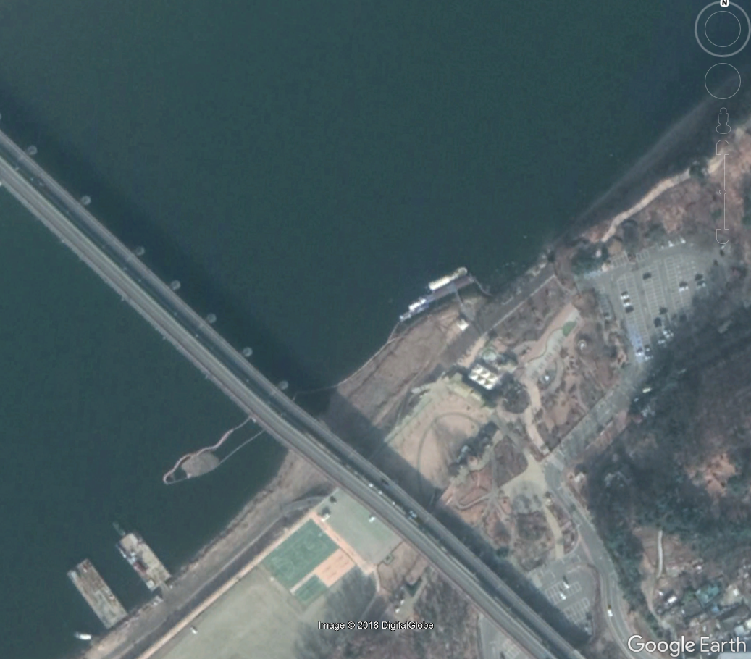

Figure 3 Google image

* Landsat images (resolution 30 m) from USGS will be used if aerial images are not available

**Land use maps (Week 19)**

* Land use maps are served at Ministry of Environment
* Maps are only accessible within Korean IP address
* Land use maps of 2007 and 2012, made of KOMPSAT-2 and SPOT-5 satellites, have each 5 metre resolution
* Land use categories are pre-classified to seven categories
  + Urbanisation area, Agricultural area, Forest, Grassland, Wetland, Barren land, Water body
  + In agriculture category, agricultural types are regionally different, this needs to break down to three divisions.
    - Rice field and field
    - Intensive facilities
    - Orchard and etc.

**Korean Literature review and extra days (Week 20)**

* Some old documents are required to make a visit to library
* This week can be used for any related works in case prolonged or unexpected situations

**Fieldwork to the Nakdong River and catchments (Week 25)**

* Within catchments, different land uses type needs to be clearly shown
* Take pictures of land use, developed areas in the river (reclaimed island in a channel, developed areas, straightened channel, weirs, etc.) to show characteristics of the study area
* Physical characteristics and setting need to be address at diatom sampling sites